Women Soaring Pilots Association
The purpose of the Women Soaring Pilots Association is to promote all aspects of soaring to women glider pilots.

The purpose of the Women Soaring Pilots Association is to promote all aspects of soaring for women glider pilots.

Women Soaring Pilots Association 46th Annual Seminar Registration
Sunflower Aerodrome, Hutchinson, Kansas
July 22-26, 2024

Each person attending must fill out a separate registration form, whether a “flying” or a “non-flying” participant.

Check one: □ Pilot □ Non-Flying Participant □ Volunteer
Name: ________________________________________________________________________________________
Address (Street, City, Zip, Country): _________________________________________________________________
Home Phone: ____________________________________
Cell Phone: ______________________________________
Email Address: ____________________________________________________________
Emergency Info:
Emergency Contact: ________________________________________
Relationship: ______________________________________________
Will they be on the Field? (Check one): □ Yes □ No
Their Phone Number(s): Home ____________________________ Cell: ______________________________
Their Address (Street City Zip): _______________________________________________________________
Your relevant medical information: _______________________________________________________________
____________________________________________________________________________________________
Pilot Experience:
US (FAA) Pilot Certificate? □ Yes □ No Certificate Number: _______________________________
US (FAA) Pilot Certificate Type: □ Student □ PPL □ Commercial □ CFIG
Pilot Certificate from another country? □ Yes □ No Certificate Number: _______________________________
Total Glider PIC hours: _____________________ Total hours THIS year: ______________________________
Date last Flight Review: ____________________ Highest FAI Badge: _________________________________
Aircraft Information (if bringing a glider):
Manufacturer: ___________________________ Model: _________________________________________
Registration/N Number: ___________________ Tail ID: _________________________________________
Insurance Carrier: ________________________ Policy #_________________________________________
Policy Expiration Date: ____________________ Owner: _________________________________________
* Please bring proof of Insurance which will be required on site prior to flight.
* If bringing a glider owned by another, please bring a letter signed by the owner authorizing your use of the glider.
Flying:
To fly solo, a US License and current Flight Review are required.
(Check all that apply.) I would like to fly (Check all that apply):
□ With a CFIG □ With a Local Pilot □ Solo □ Want a Flight Review □ Need an Examiner for a License
Page 1
Please choose your Seminar Goals (Check all that apply): Page 2
□ Basic Instruction □ Improve Thermalling skills □ FAI Badge Work: Which Badge or Leg? _____________
□ Spot Landings for C or Bronze Badge □ Flight Maneuvers you would like to work on ________________
□ Close to solo & would like to solo at seminar □ Need a Flight Review
□ Back seat check-out □ Local X-Country - Choices: □ Dual □ Solo □ Lead & Follow X-C
□ Auto Tow □ Complete a Check-ride (Private, commercial, CFIG): Please specify ________________
□ Glider Add-on (power pilot) □ Other Goals: Please specify: _________________________________
When can we expect you?
Planned Arrival Date: ____________________________ Planned Departure Date: ___________________________
Lodging Plans: It’s up to you to book your own lodging or RV. However, we would like to know where you’ll be staying, as this helps us coordinate daily ride-sharing to the airport and the possible sharing of rooms if you’d like to save money.
Are you looking for a roommate to share a room? □ Yes □ No
Are you willing to share your RV? □ Yes □ No (See below)
1. Camping at Sunflower w/ RV or Tent? Contact Leah Condon for a space reservation: Leah.N.Condon@gmail.com
2. Other Plans: _________________________
Seminar T-Shirts:
Included with registration is one (1) T-shirt. Additional T-shirts are available for order. Available sizes are S, M, L, XL, and XXL. Please indicate the size of your seminar shirt and the number of additional shirts you would like to order. (Blue boxes).
Add this amount to the chart below. See the *
Product | Unisex Sizes (S, M, L, XL, XXL): | Quantity | Cost
Seminar shirt included with registration | Size  ________________ | 1 ________________- | No extra cost.
*Optional: Additional Shirt(s)  $30/each | Size(s)  _____ _____ _____ | ___________ | Total: ___________*

Want to order more shirts? □ Please check here if you’d like someone to contact you for a larger order.
Registration Cost: (Flying costs ( e.g., tows, instruction, retrieves, rentals) are separate from this and will be billed during the seminar.)

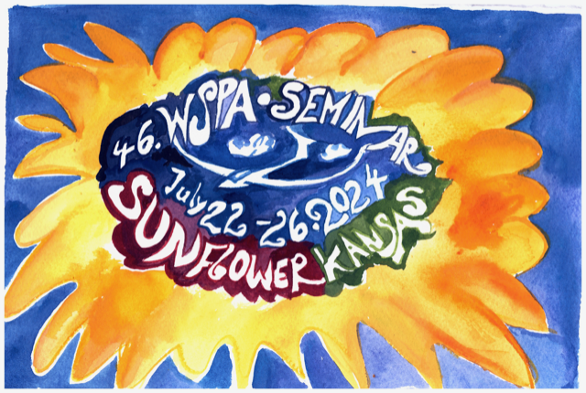

Page 3

Membership in the WSPA is required for registration. For flying participants, membership in the SSA is required (contact Leah Condon if you need assistance joining SSA).Registration for flying participants includes one seminar T-shirt, KSA membership, seminar materials and instructional classes, meals Mon-Fri, including the WSPA Banquet on Friday night, prizes, & a donation to the Briegleb Scholarship, which pays for one Seminar Scholarship next year.
Registration for Non-flying participants includes breakfast, lunch & dinner Mon-Fri, including the WSPA Banquet on Friday night, the T-shirt, Briegleb Scholarship donation, and the WSPA membership.
□ Please check here if you are registering and are using a WSPA Scholarship to help pay fees.
Please get in touch with the WSPA treasurer at treasurer@womensoaring.org to confirm.

REGISTRATION FEE

Please register before July 1, 2024. Late registrations and payments will not guarantee a seminar t-shirt in your size.

If you are not yet a member or need to renew your membership, first go to:

WSPA Membership Application & Renew
Womensoaring.org

And follow the steps to become a WSPA member or update your membership.

WSPA ANNUAL DUES
- Full Members & Associate Members (Mail In, Zelle) $25.00
- Full Members & Associate Members (PayPal) $28.00
- Youth Members (Under 19) (Mail In, Zelle) $10.00
- Youth Members (under 19) (PayPal) $11.00
- Life Members (Mail In, Zelle) $350.00
- Life Members (PayPal) $365.00

SEMINAR PARTICIPANTS FEES – WSPA MEMBERS
- Flying (Mail In, Zelle) $450.00
- Flying (PayPal) $464.00

SEMINAR PARTICIPANTS FEES – NON-FLYING
- Non-Flying (Mail In, Zelle) $325.00
- Non-Flying (PayPal) $336.00

WRITING A CHECK TO WSPA
- Checks to WSPA should be written to the order of WOMEN’S SOARING PILOTS ASSOCIATION.
- On the Memo line write the purpose of the check.

MAILING A CHECK OR DOCUMENT TO WSPA
- Send Payment correspondence to:

Margarett Roy, WSPA Treasurer
PO Box 1197
Central Islip, NY 11722-0950

- At the bottom left corner of the envelope, write “ATT: WSPA.”

Page 4

USING ZELLE
- Payments are to be sent to “ treasurer@womensoaring.org”.
- On the Note of the Zelle transaction, write “WSPA membership payment” or any other purpose.
- Additional tee shirts are $30 each while supplies last.

MAKE CHECK OR MONEY ORDER TO: WSPA

Total Payment Towards Registration________________________________________
Optional Additional Donation to the WSPA Scholarship Fund____________________
Total Payment__________________________________________________________

Important Notes:

- Daily Flying costs will be paid separately and in total before leaving the Seminar. Please refer to the information sheet for glider rental and instruction rates, cost of tows, and other relevant information.
- SOON TO BE PROVIDED ON www.womensoaring.org
- OR CONTACT LEAH CONDON @ Leah.N.Condon@gmail.com
- WSPA Liability Waiver: All attendees will fill out this form upon arrival.

More Information:
Additional Seminar details will soon be available at www.womensoaring.org.
If you have questions, please email Leah Condon, Seminar Coordinator
Contacts:
Leah Condon, WSPA Seminar Hostess, Leah.N.Condon@gmail.com
Lynda Lee LaBerge WSPA President, Lyndaleelaberge@gmail.com 770-313-4865
Sylvia Grandstaff WSPA Vice President, sylviagrandstaff@gmail.com

LOOKING FORWARD TO SEEING YOU IN KANSAS!

